

**COMSATS University Islamabad, Lahore Campus**

**Subject:**

OOP.

**Submitted to**:

Sir Shahid Bhatti.

**Submitted by**:

Hamdan Zulfiqar (SP24-BSE-032)

**Section**:

‘A’

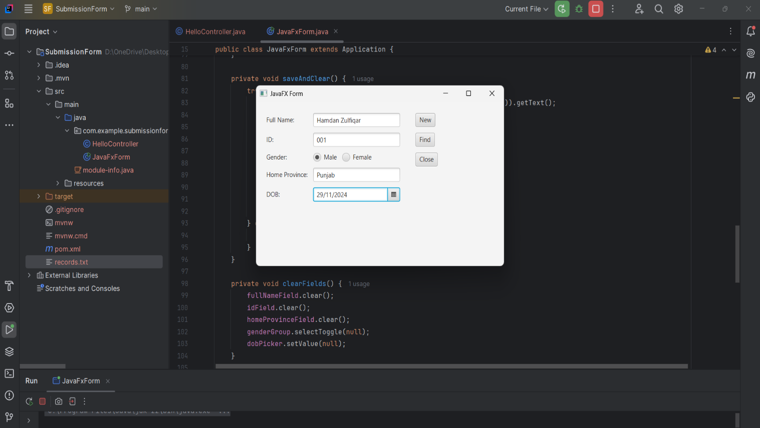

Enter the information and click on the new button to write the data into records.txt file.

If user wants to find the information of any person, write the id of the person you entered earlier and then click on the find button.

The data on the form will be written in records.txt file.

**Source Code:**

package com.example.submissionform;  
  
import javafx.application.Application;  
import javafx.geometry.Insets;  
import javafx.scene.Scene;  
import javafx.scene.control.*;  
import javafx.scene.layout.*;  
import javafx.stage.Stage;  
  
import java.io.*;  
import java.nio.file.Files;  
import java.nio.file.Paths;  
import java.util.List;  
  
public class JavaFxForm extends Application {  
 private TextField fullNameField, idField, homeProvinceField;  
 private ToggleGroup genderGroup;  
 private DatePicker dobPicker;  
 private File file = new File("records.txt");  
  
 public static void main(String[] args) {  
 *launch*(args);  
 }  
  
 @Override  
 public void start(Stage stage) {  
 // Creating input fields  
 fullNameField = new TextField();  
 idField = new TextField();  
 homeProvinceField = new TextField();  
 dobPicker = new DatePicker();  
  
 // Gender radio buttons  
 RadioButton maleButton = new RadioButton("Male");  
 RadioButton femaleButton = new RadioButton("Female");  
 genderGroup = new ToggleGroup();  
 maleButton.setToggleGroup(genderGroup);  
 femaleButton.setToggleGroup(genderGroup);  
  
 // Creating buttons  
 Button newButton = new Button("New");  
 Button closeButton = new Button("Close");  
 Button findButton = new Button("Find");  
  
 // Layout setup  
 GridPane grid = new GridPane();  
 grid.setPadding(new Insets(10));  
 grid.setHgap(10);  
 grid.setVgap(10);  
  
 grid.add(new Label("Full Name:"), 0, 0);  
 grid.add(fullNameField, 1, 0);  
 grid.add(new Label("ID:"), 0, 1);  
 grid.add(idField, 1, 1);  
 grid.add(new Label("Gender:"), 0, 2);  
 HBox genderBox = new HBox(10, maleButton, femaleButton);  
 grid.add(genderBox, 1, 2);  
 grid.add(new Label("Home Province:"), 0, 3);  
 grid.add(homeProvinceField, 1, 3);  
 grid.add(new Label("DOB:"), 0, 4);  
 grid.add(dobPicker, 1, 4);  
  
 VBox buttonBox = new VBox(10, newButton, findButton, closeButton);  
 buttonBox.setPadding(new Insets(10));  
  
 HBox root = new HBox(10, grid, buttonBox);  
 root.setPadding(new Insets(10));  
  
 // Button actions  
 newButton.setOnAction(e -> saveAndClear());  
 closeButton.setOnAction(e -> stage.close());  
 findButton.setOnAction(e -> findRecord());  
  
 // Scene setup  
 Scene scene = new Scene(root, 500, 300);  
 stage.setScene(scene);  
 stage.setTitle("JavaFX Form");  
 stage.show();  
 }  
  
 private void saveAndClear() {  
 try (FileWriter writer = new FileWriter(file, true)) {  
 String gender = ((RadioButton) genderGroup.getSelectedToggle()).getText();  
 String record = String.*format*("%s,%s,%s,%s,%s%n",  
 fullNameField.getText(),  
 idField.getText(),  
 gender,  
 homeProvinceField.getText(),  
 dobPicker.getValue());  
  
 writer.write(record);  
 clearFields();  
 } catch (IOException e) {  
 showAlert("Error", "Failed to save record.");  
 }  
 }  
  
 private void clearFields() {  
 fullNameField.clear();  
 idField.clear();  
 homeProvinceField.clear();  
 genderGroup.selectToggle(null);  
 dobPicker.setValue(null);  
 }  
  
 private void findRecord() {  
 String idToFind = idField.getText();  
 if (idToFind.isEmpty()) {  
 showAlert("Error", "Please enter an ID to find.");  
 return;  
 }  
  
 try {  
 List<String> records = Files.*readAllLines*(Paths.*get*(file.toURI()));  
 for (String record : records) {  
 String[] fields = record.split(",");  
 if (fields[1].equals(idToFind)) {  
 fullNameField.setText(fields[0]);  
 idField.setText(fields[1]);  
 homeProvinceField.setText(fields[3]);  
 dobPicker.setValue(java.time.LocalDate.*parse*(fields[4]));  
 genderGroup.selectToggle(fields[2].equals("Male") ? genderGroup.getToggles().get(0) : genderGroup.getToggles().get(1));  
 return;  
 }  
 }  
 showAlert("Not Found", "No record found with the given ID.");  
 } catch (IOException e) {  
 showAlert("Error", "Failed to read records.");  
 }  
 }  
  
 private void showAlert(String title, String message) {  
 Alert alert = new Alert(Alert.AlertType.*INFORMATION*);  
 alert.setTitle(title);  
 alert.setContentText(message);  
 alert.showAndWait();  
 }  
}